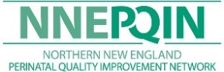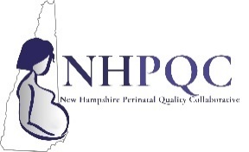                     cid:image010.jpg@01D70AC8.DE2A2580                    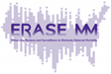

A Dartmouth Health Program



**NH AIM/ERASE MATERNAL MORTALITY**

**2024 MONTHLY WEBINAR SERIES**

NNEPQIN and the NHPQC are partnering with NH DHHS and 2 national initiatives, CDC’s ERASE Maternal Mortality & The Alliance for Innovation on Maternal Health (AIM) to eliminate preventable maternal mortality and severe maternal morbidity.  We host monthly webinars on the 2nd Thursday of each month from Noon – 1PM to provide education and share ideas.

Register now and watch for email invitations for additional details on the following topics!

**August 8, 2024**  **Why a comprehensive SDoH assessment improves your ability to address mental health concerns.**

[August Registration Here](https://dhvideo.webex.com/weblink/register/r6c85e1ac479c439b50f2f2609c92efba)

**September 12, 2024 The legal requirements and approaches for providing linguistically appropriate care.**

[September Registration Here](https://dhvideo.webex.com/weblink/register/r3ed955a7b168db8b1552cebaacb159ed)

**October 10, 2024** **Creating comprehensive postpartum support in these challenging times.**

[October Registration Here](https://dhvideo.webex.com/weblink/register/r740bc120bbf6b34e3ae343fe714ce9dd)

**November 14, 2024 A multidisciplinary team approach to more effective discharge planning.**

[November Registration Here](https://dhvideo.webex.com/weblink/register/r40098d5eb611af9e7b11ddaecdf8afff)

**December 12, 2024 The importance of improving our birth certificate data collection.**

[December Registration Here](https://dhvideo.webex.com/weblink/register/rf8e1bc9968df9d2bd2531e10ac80fead)

Join us from Noon – 1PM on these dates for great interactive educational sessions. Bring your best practices, ideas and questions!

**Questions:** [Stephanie](mailto:Stephanie).E.Langlois@hitchcock.org or [Julie.S.Bosak@hitchcock.org](mailto:Julie.S.Bosak@hitchcock.org) or [NHPQC@hitchcock.org](mailto:NHPQC@hitchcock.org) Phone: 603-308-9469 Web: [Educational Offerings | NNEPQIN](https://www.nnepqin.org/events-projects/)

**Learning Outcome:**

At the end of this series, 100% of learners will be able to discuss at least three recent updates regarding maternal mortality in New Hampshire.

**Accreditation:**

In support of improving patient care, Dartmouth Health is jointly accredited by the Accreditation Council for Continuing Medical Education (ACCME), the Accreditation Council for Pharmacy Education (ACPE), and the American Nurses Credentialing Center (ANCC), to provide continuing education for the healthcare team.

American Medical Association (AMA) Dartmouth Health designates this live activity for a maximum *of 1.0 AMA PRA Category 1 Credit(s)™.* Physicians should claim only the credit commensurate with the extent of their participation in the activity.

American Nurses Credentialing Center (ANCC) Dartmouth Health designates this live activity for a maximum of 1 ANCC contact hours.